Microcontroller Code Block
ECE44x Wearable Sensor for The Blind Group 34

Keywords—Microcontroller Code; block description; design verification

Introduction
The purpose of this document is to describe how the microcontroller code will behave on the working system. the code will consist of all the other code, first it will be from the magnetometer to identify the front of the module, then based on that the modul of ultrasonic or laser will be set as front to determine if within proximity, the all of the incoming data beside the front also be recorded, then sendt to the haptic feedback through bluetooth. This document will be used to overview of all the function, properties, schematic, and verification of the design, so that the future use of the sensor can be simplyfy.

Block Overview
The Microcontroller code does not have any physical block that can be intreped in the block view diagram, therefore its hard to specify of how it will behave outside the physical. in code it will be something like on figure 1.

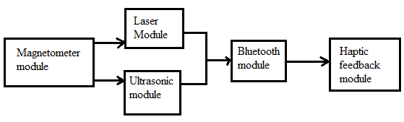
- Black Box Diagram of Controller Code Block
- Display Block Interfaces and Properties

Verification
Based on the interfaces for this block, a verification (testing) process needs to be indicated. This will allow for the final constructed design to be tested verifying that all of the interface properties have been met and that the block is ready for integration into the system

Testing
Link to Video
The block will be categorized as pass, when all the testing was pass.

Design
The Wiring Diagram (Fig. 2) presents the block design, including the interfaces of the block. These interfaces are further elaborated through validation information given in Table 2, which demonstrates externaly-supported validy for each of the block’s properties. While the Pulse diagram (Fig.3), is to demonstrated how the ultrasonic module pulse works.

Wiring Diagram
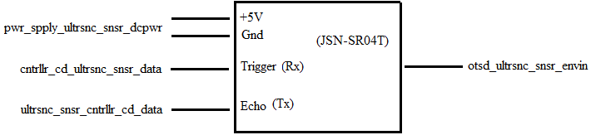
- Wiring Diagram for the Ultrasonic Module Block

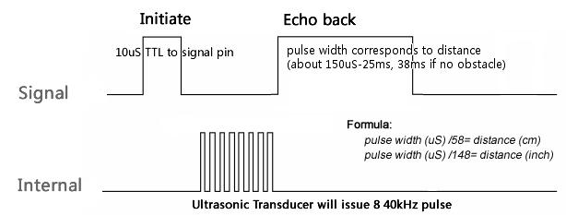
- Pulse Diagram for the Ultrasonic Module Block

Design Validation
For this block, the Ultrasonic sensor Module that being chooses is JSN-SR04T sensor. That sensor was chosen because it fits the water resistance, distance measurement, accuracy, and the angle of detection. The table below (Tabel2), will validate the needed of each block
.

- Interface Property Validation for the ultrasonic sensor Block
Property | Validation
pwr_spply_ultrsnc_snsr_dcpwr
Min Voltage: 3 V | Datasheet specification said min voltage is 3 V [1]
Max Voltage: 5.5 V | Datasheet specification said maximum voltage is 5.5 V [1]
Nominal Current: 5mA | Datasheet specification said current nominal is 5mA[1]
Peak Current: 30mA | Datasheet specification said maximum corrent is 30 mA [1]
otsd_ultrsnc_snsr_envin
Probe freq: 40KHz | Datasheet specification said that the frequency of ultrasound is 40KHZ [1]
Range: 20 cm - 500cm | Although the datasheet said it possible to 600cm, what the project needed is 500 cm
Range accuracy : 10cm | Since the accuracy of the object that needed to detect is 1 meter width, 10 cm accuracy will be sufficient enough
Angle: 75 degree | Datasheet specification said that angle of the ultrasonic is 75 degree [1]
cntrllr_cd_ultrsnc_snsr_data
Pulse Protocol :TTL | Datasheet specification said that Tine-to-Life type (TTL) of signal [1]
Pulse width :10 uS | Datasheet specification said width of TTl is 10 uS [1]
Pulse Voltage: 5 V | Based on the usual 1 or 0 , a microcontroller use about 4.5~5.5 volt to identify as 1
Messages: Trigger Measurement: 0x55 (1010 1010b) | Datasheet specification said it transmit a 10101010 data to set the pulse to work [1]
ultrsnc_snsr_cntrllr_cd_data
Echo Protocol: TTL | Datasheet specification said that Tine-to-Life type (TTL) of signal [1]
Echo width :150us~25ms (38ms no obstacle) | Datasheet specification said width of TTl is about 150 uS to 25mS , and 38mS of no obstacle[1]
Echo Voltage: 5 V | Based on the usual 1 or 0 , a microcontroller use about 4.5~5.5 volt to identify as 1
Echo Level During Measurement: 1 | Datasheet specification said it need to transmit a time delay to microcontroller to calculate the distance [1]

- bill of materials

REFERENCES

- Adruino, “JSN-SR04T 20-60 0cm ultrasonic waterproof Range Finder ” JSN-SR04T Datasheet, https://drive.google.com/a/oregonstate.edu/file/d/1mWfcWH5f5-8lk2r7KeLZ4dzk0CqiVCk0/view?usp=sharing

